**Lab Report No 4**



**Digital Signal processing**

**Submitted By: Muhammad Ali**

**Registration No: 19pwcse1801**

**Section: A**

**“On my honor , as student of University of Engineering and**

**Technology, I have neither given nor received unauthorized assistance on this**

**Department of Computer Systems Engineering**

**University of Engineering and Technology Peshawar**

**CSE 402L: Digital Signal Processing**

|  |  |  |  |  |
| --- | --- | --- | --- | --- |
| **Accuracy** | The student completed (  <50%) tasks and provided  MATLAB code and/or Simulink models with errors. Outputs shown are not correct in form of graphs (no labels) and/or tables along with incorrect analysis or remarks. | The student completed partial tasks (50% - <90%) with accurate MATLAB code and/or Simulink models. Correct outputs are shown in form of graphs (without labels) and/or tables along with correct analysis or remarks. | The student completed all required tasks (90%-100%) with accurate MATLAB code and/or Simulink models. Correct outputs are shown in form of labeled graphs and/or tables along with correct analysis or remarks. | **30%** |
| **Following**  **Directions** | The student clearly failed to follow the verbal and written instructions to successfully complete the lab | The student failed to follow the some of the verbal and written instructions to successfully complete all requirements of the lab | The student followed the verbal and written instructions to successfully complete  requirements of the lab | **20%** |
| **Time Utilization** | The student failed to complete even part of the lab in the allotted amount of time | The student failed to complete the entire lab in the allotted amount of time | The student completed the lab in its entirety in the allotted amount of time | **20%** |

|  |  |  |  |  |  |
| --- | --- | --- | --- | --- | --- |
| **Demonstration**  **Concepts** | **of** | **Poor (Does not meet expectation (1))**  The student failed to demonstrate a clear understanding of the  assignment concepts | **Fair (Meet**  **Expectation (2-3))**  The student demonstrated a clear understanding of some of the assignment  concepts | **Good (Exceeds**  **Expectation (4-5)**  The student demonstrated a clear understanding of the assignment concepts | **Score**  **30%** |

**Tasks no 1-4: -**

% code for sinusiod of frequency 10,30,50 and its fourier transform

t=0:1/1000:1;

A=1;

signal1 = A*sin(2*pi*10*t);

subplot(311);

plot(t,signal1);

title('sinusiod of frequency 10Hz in time-domain');

xlabel('time');

ylabel('Amplitude');

signal2 = A*sin(2*pi*30*t)

subplot(312);

plot(t,signal2);

title('sinusiod of frequency 20Hz in time-domain');

xlabel('time');

ylabel('Amplitude');

signal3 = A*sin(2*pi*50*t);

subplot(313);

plot(t,signal3);

title('sinusiod of frequency 50Hz in time-domain');

xlabel('time');

ylabel('Amplitude');

% fourier transform of above signals having frequency 10,30,50

figure;

fouriertransform=fft(signal2,length(signal1));

n=length(fouriertransform);

ftshift=(-n/2:n/2-1)*(1000/n);

signalshift=(fftshift(fouriertransform));

absvalue=abs(signalshift);

subplot(311);

plot(ftshift,absvalue);

title('sinusiod of frequency 10Hz in frequency-domain');

xlabel('frequency');

ylabel('Amplitude');

fouriertransform=fft(signal2,length(signal2));

n=length(fouriertransform);

ftshift=(-n/2:n/2-1)*(1000/n);

signalshift=(fftshift(fouriertransform));

absvalue=abs(signalshift);

subplot(312);

plot(ftshift,absvalue);

title('sinusiod of frequency 30Hz in frequency-domain');

xlabel('frequency');

ylabel('Amplitude');

fouriertransform=fft(signal3,length(signal3));

n=length(fouriertransform);

signalshift=(fftshift(fouriertransform));

ftshift=(-n/2:n/2-1)*(1000/n);

signalshift=(fftshift(fouriertransform));

absvalue=abs(signalshift);

subplot(313);

plot(ftshift,absvalue);

title('sinusiod of frequency 50Hz in frequency-domain');

xlabel('frequency');

ylabel('Amplitude');

% code for sinusiods of frequency 20,40,60 and its fourier transform

figure;

t=0:1/1000:1;

A=1;

signal1 = A*sin(2*pi*20*t);

subplot(311);

plot(t,signal1);

title('sinusiod of frequency 20Hz in time-domain');

xlabel('time');

ylabel('Amplitude');

signal2 = A*sin(2*pi*40*t)

subplot(312);

plot(t,signal2);

title('sinusiod of frequency 40Hz in time-domain');

xlabel('time');

ylabel('Amplitude');

signal3 = A*sin(2*pi*60*t);

subplot(313);

plot(t,signal3);

title('sinusiod of frequency 60Hz in time-domain');

xlabel('time');

ylabel('Amplitude');

% fourier transform of above signals having frequency 20,40,60

figure;

fouriertransform=fft(signal2,length(signal1));

n=length(signal1);

ftshift=(-n/2:n/2-1)*(1000/n);

signalshift=(fftshift(fouriertransform));

absvalue=abs(signalshift);

subplot(311);

plot(ftshift,absvalue);

title('sinusiod of frequency 20Hz in frequency-domain');

xlabel('frequency');

ylabel('Amplitude');

fouriertransform=fft(signal2,length(signal2));

n=length(signal2);

ftshift=(-n/2:n/2-1)*(1000/n);

signalshift=(fftshift(fouriertransform));

absvalue=abs(signalshift);

subplot(312);

plot(ftshift,absvalue);

title('sinusiod of frequency 40Hz in frequency-domain');

xlabel('frequency');

ylabel('Amplitude');

fouriertransform=fft(signal3,length(signal3));

n=length(signal3);

ftshift=(-n/2:n/2-1)*(1000/n);

signalshift=(fftshift(fouriertransform));

absvalue=abs(signalshift);

subplot(313);

plot(ftshift,absvalue);

title('sinusiod of frequency 60Hz in frequency-domain');

xlabel('frequency');

ylabel('Amplitude');

**Plot: -**

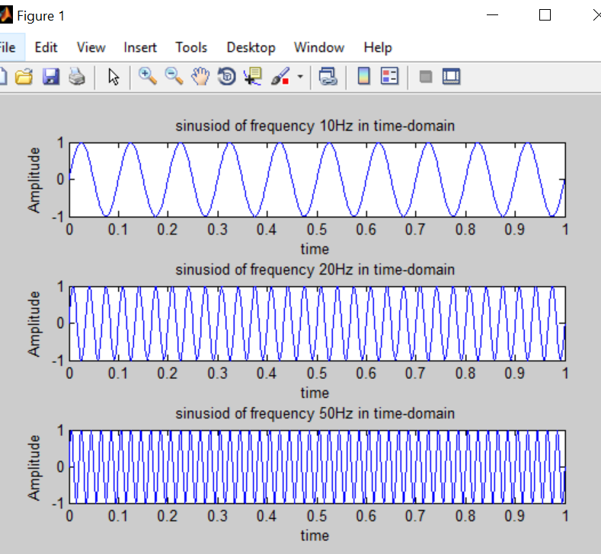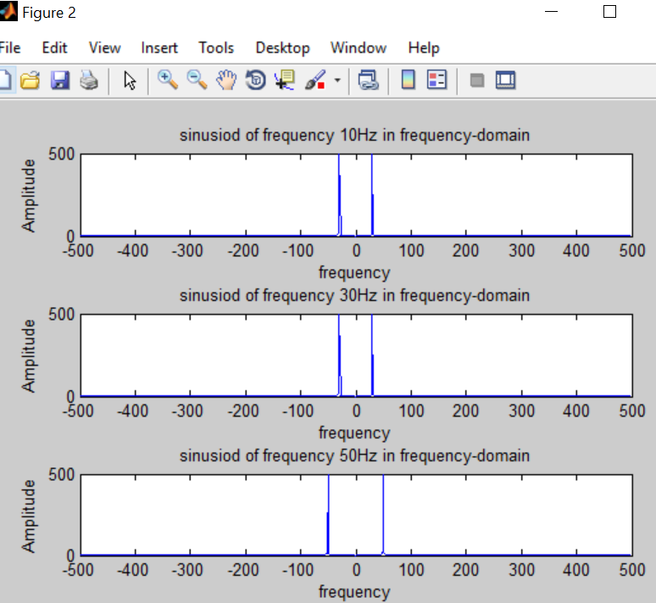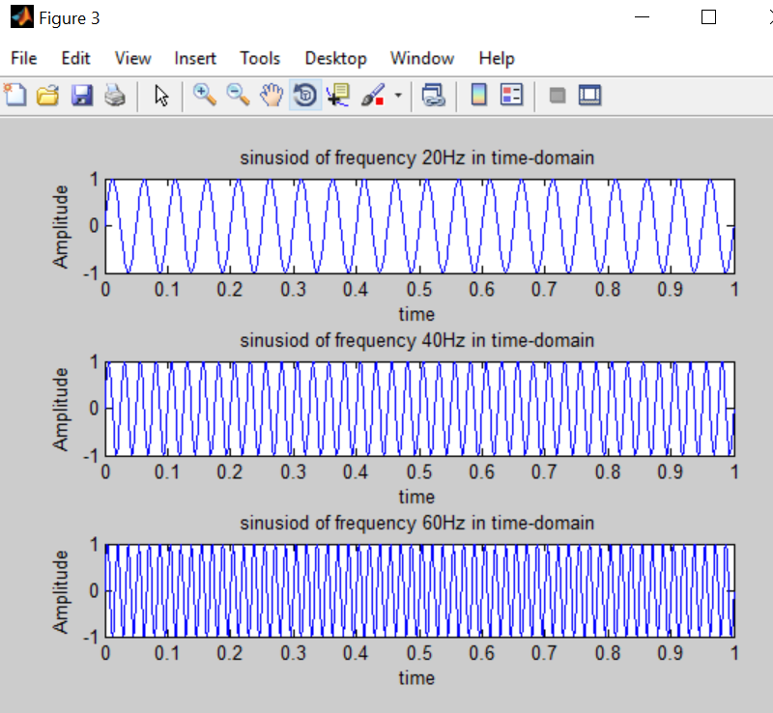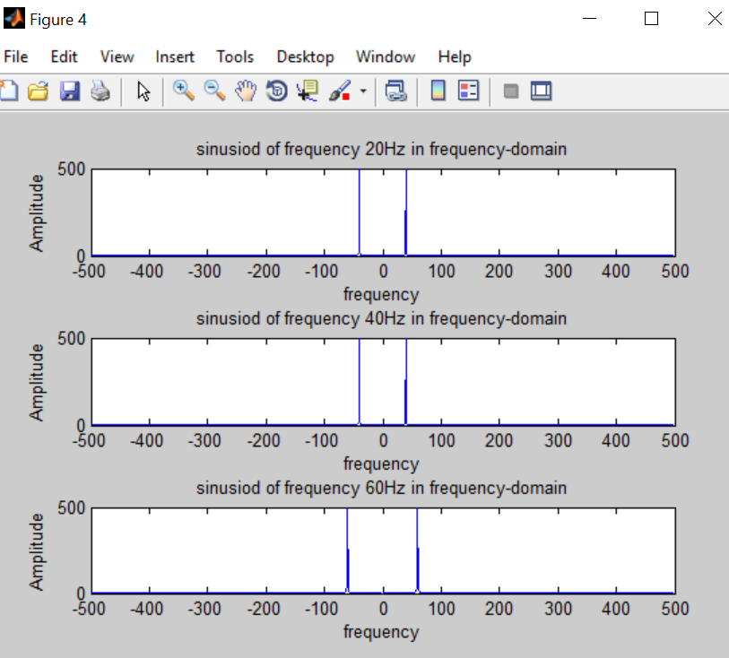

**Task no 4-8: -**

% code for sinusiod of frequency 10,30,50 and its fourier transform

t=0:1/1000:1;

A=1;

signal1 = A*sin(2*pi*10*t);

subplot(311);

plot(t,signal1);

title('sinusiod of frequency 10Hz in time-domain');

xlabel('time');

ylabel('Amplitude');

signal2 = A*sin(2*pi*30*t)

subplot(312);

plot(t,signal2);

title('sinusiod of frequency 20Hz in time-domain');

xlabel('time');

ylabel('Amplitude');

signal3 = A*sin(2*pi*50*t);

subplot(313);

plot(t,signal3);

title('sinusiod of frequency 50Hz in time-domain');

xlabel('time');

ylabel('Amplitude');

composite1=signal1+signal2+signal3;

%step no 3,4: code for sinusiods of frequency 20,40,60 and its fourier transform

figure;

t=0:1/1000:1;

A=1;

signal1 = A*sin(2*pi*20*t);

subplot(311);

plot(t,signal1);

title('sinusiod of frequency 20Hz in time-domain');

xlabel('time');

ylabel('Amplitude');

signal2 = A*sin(2*pi*40*t)

subplot(312);

plot(t,signal2);

title('sinusiod of frequency 40Hz in time-domain');

xlabel('time');

ylabel('Amplitude');

signal3 = A*sin(2*pi*60*t);

subplot(313);

plot(t,signal3);

title('sinusiod of frequency 60Hz in time-domain');

xlabel('time');

ylabel('Amplitude');

composite2=signal1+signal2+signal3;

figure;

subplot(211);

composite=composite1+composite2;

plot(t,composite);

title('composite signal in time-domain');

xlabel('time');

ylabel('Amplitude');

%fourier transform of composite signal

subplot(212);

ft= fft(composite,length(composite));

signalshift=(fftshift(ft));

n=length(composite);

ftshift=(-n/2:n/2-1)*(1000/n);

abvalue=abs(signalshift);

plot(ftshift,abvalue);

%step no 5: plot comfirm that all factor included in the plot

%step no 6: generating noise signal

figure;

noise1=0.5*sin(2*pi*80*t);

noise2=0.7*sin(2*pi*100*t);

noise= noise1 + noise2;

subplot(211);

plot(t,noise);

title('noise in time-domain');

xlabel('time');

ylabel('Amplitude');

% fourier transform of noise

fof_n=fft(noise,length(noise));

signalshift=(fftshift(fof_n));

n=length(noise);

ftshift=(-n/2:n/2-1)*(1000/n);

abv=abs(signalshift);

subplot(212);

plot(ftshift,abv);

title('noise in frequency-domain');

xlabel('time');

ylabel('Amplitude');

%step no 7: add noise to composite signal

figure;

subplot(211);

sum=noise+composite;

plot(t,sum);

title('noise+ composite in time-domain');

xlabel('time');

ylabel('Amplitude');

% fourier transform of noise +composite signal

subplot(212);

fof_noiesandcomposite=fft(sum,length(sum));

signalshift=(fftshift(fof_noiesandcomposite));

n=length(sum);

ftshift=(-n/2:n/2-1)*(1000/n);

abvalue=abs(signalshift);

subplot(212);

plot(ftshift,abvalue);

title('noise + composite in frequency-domain');

xlabel('time');

ylabel('Amplitude');

**plot: -**

